|  |
| --- |
|  |
| Project Title (HyperTecnho: Product Digital Hearing Aid) |
| A Proposal Submitted to the ITAC Collaborative Research Fund as an [ ARP] |
|  |
|  |

Cairo University

Facultyof Engineering

[Signature]

[Principal Investigator’s Name]

[Title]

[Signature]

[Industrial Partner Representative]

[Title]

[Signature]

[Faculty Dean’s or Unit Director’s Name]

[Title]

Table of Contents

Disclosure Statement 3

Proposal Ownership 3

Consent Statement 3

Statement for Non-Plagiarism 3

Abstract 4

1 Introduction 5

2 Industry Analysis and Proposal Objectives 6

2.1 History and State-of-the-Art 6

2.2 Industry and Market Analysis 6

2.3 Proposal Objectives 6

2.4 Marketing Strategy 6

3 Statement of Proposed Research 6

3.1 Detailed Research Proposal 6

3.2 Detailed SMART Objectives/Deliverables 6

4 Methodology and Execution Plan 7

4.1 The Starting Point: [Select Idea/Proof-of-Concept/Prototype] 7

4.2 Technical Methods/Approaches 7

4.3 Work Packages and Reporting Scheme 7

4.4 Milestones and Gantt Chart 7

4.5 SWOT Analysis and Mitigation Plan 7

5 Resources 7

6 Budget 8

6.1 Distribution by Item 8

6.2 Distribution by Milestone 8

6.3 Projected Income/ROI/Financial Plan 8

7 References 8

8 Appendices 8

9 Biographies 8

# Disclosure Statement

Please use this part to share with the ITAC Program any information relevant to applications filed by the project team to other funding agencies (local or international), before or during the processing of this proposal by the ITAC. If previous funds were received for a project in the same technology, the project team should state this here and provide the details of the deliverables of the funded project in an appendix to this proposal.

If there are none, please use the following statement in this section:

“The applicants of this proposal confirm that the deliverables of the proposed project have not been achieved before the time of submitting this proposal and, if approved for funding, will be genuine outcomes of the proposed project. No applications have been filed by the project team to any other funding agency, local or international, within the broad scope of the technology under investigation in this proposal.”

# Proposal Ownership

Please use this part to clarify who initiated the proposal idea and who is thus its owner. In case the partnership did not succeed, this part should clarify the rights of the owner to seek another partner and resubmit the proposal in another round. A suggested statement:

“The applicants hereby attest that the proposal idea was initiated and owned by [ServoMed]. In the unfortunate case where the partnership ends, the [specify] has the right to seek another partner and resubmit the proposal in the same or a subsequent round.”

# Consent Statement

“The applicants are aware that the proposal evaluation process involves sharing the proposal documents with the assigned technical reviewers. Also parts of the proposal may be shared with other funding agencies as part of coordination and integration activities in case of similarities with other projects conducted by the project team members.”

# Statement for Non-Plagiarism

The contents of this proposal are prepared and presented in accordance with the non-plagiarism practices and ethical conduct known within the research community. The applicants of this proposal hereby attest of this proposal is their genuine writing, including due referencing to relative sources with no verbatim copy of material (including previous works of the applicants). The applicants are also aware that violation of such practices may result in blacklisting the applicants, i.e., automatic rejection of any future proposals, and notification of their institutions with such conduct.

# 

# Abstract

The most basic function of a hearing aid is to amplify sound. Digital hearing aids do this in a rather sophisticated way. As sound enters the device, it is broken into multiple frequency bands. Each band is then amplified by the amount necessary to return the wearer's hearing to normal levels at that band.

With digital technology, devices can now break sound into as many as 24 different bands. Given that every person has a unique pattern of hearing loss, the sound quality provided by a modern hearing aid is far better the previous analogue technologies that were restricted to two bands - base (low frequencies) and treble (high frequencies).

Our Project should lie within the following areas

Digital Signal Processing (DSP) and Embedded Systems for ICT Applications, ICT for Health, Mobile Applications and (DSP)

An adaptable Digital hearing aid that allows the dynamic change of its amplification by the user will benefit ICT industry. Moreover, it will be less costly than an analogue prefixed hearing aid that requires constant changing to adapt with the patient’s changing state

We provide a long term device which does not need continuous calibration or doctor visits, because the patient can adjust it anytime anywhere.

We offer the product at a much lower price. At 15 USD per piece the price is unmatched given that it does not need to be replaced to adjust for change in patient’s status.

We have no competitors within the Egyptian market, which would make us pioneers in this field in Egypt.

**Our objective is 2 separate Products:**

Firstly: is mainly a mobile app that helps hearing impaired persons to amplify the frequencies they don’t hear well by the help of a smart phone and a neat Bluetooth headset

Secondly: is a complete standalone headset (Hardware) that works as a Digital Hearing Aid and controllable by a standalone mobile app via Bluetooth

# Introduction

First Part

Hearing impairment is one of the commonest birth defects. It is the third leading chronic disability affecting nearly 250 million people in the world, and 75% of sufferers live in developing countries.

The impact of hearing impairment on the individual and society is significant. Development of hearing loss leads to severe handicap that affects the sufferer’s job, home and life with subsequent social and economic burden on the society. In children the problem is compounded since normal hearing is the primary source for acquisition of language, speech and cognitive skills.

In a national household survey conducted to estimate the prevalence of hearing impairment in Egypt, it was found to be high in those aged 0-4 years (22.4%).

Proposed solution and impact:

An adaptable digital hearing aid that allows the dynamic change of its amplification by the user. Moreover, it will be less costly than an analogue prefixed hearing aid that requires constant changing to adapt with the patient’s changing state.

Latest Digital hearing aids are programmed to re-balance a wearers hearing.  As sound enters the hearing aid, it is broken into multiple frequency bands. Each band is then amplified by the amount necessary to return the wearer’s hearing to normal levels at that band.

Connectivity to mobile devices and entertainment systems

Wearers are increasingly looking for solutions to improve their ability to use their hearing aids more effectively in partnership with their mobile phones, digital radio, plasma televisions, and personal stereos (i.e. iPods and MP3 players).

In response, manufacturers have developed streamers that connect wireless devices to the user's hearing aid.   
The benefit is that this delivers improved performance in terms of speech intelligibility and sound quality as signals from the external devices are streamed directly into the hearing aid, without background noise and the need for the hearing aid to first process a sound signal.

Multiple and automatic programming

Different listening environments often call for different settings within hearing aids in order to maximize their effectiveness.

For example, when listening to music, the user would prefer to turn off features that may misinterpret elements of the music as noise.

When in a quiet room, a wearer will not need the benefit directional microphones and noise reduction to the same extent they would in a crowd at the football.

Advanced hearing aids allow the user to change the settings by pressing a small button on the device. The most advanced hearing aids will even listen to the environment and change the hearing aids settings automatically, without the wearer needing to touch or think about their hearing aids.

Second part

Hyper Technology will be led by two Freshly graduated engineers on a high level of creativity with enough experience in embedded systems and great business skills. Sales forecasts indicate that Hyper Technology will achieve sterling sales for next year and Net profit will be untarnished

**Embedded systems technical manager:** Hanna Nabil , Time-Dedication: dedicated, 24/7

**Relations and marketing manager:** Amr Ashour , Time-Dedication: dedicated , 24/7

**Academic Supervisor:** Dr. Tamer Basha ,Postdoctoral Research Fellow at Harvard Medical School , Project Manager at Crescentech Inc , Assistant Professor at Cairo University

All team members attended a 3 months long entrepreneurship course covering all of the basics needed, and we all have the knowledge and ambition to work day and night on our startup.

The team has worked together on multiple projects providing us with the experience needed to handle significant work load and function as a unit.

Our technical members have worked on many related projects and have successfully delivered satisfying results.

We have an industrial partner: ServoMed, E-mail: servomed@servomed-co.com

Servomed is a premier surgical and medical equipment distributor that provides top quality & high-tech medical equipment of leading multinational suppliers to the medical professionals in Egypt and the Middle East region. It is operating in the Egyptian Market for more than 34 years with a very long and successful track record. Its office in Cairo has a State–Of–The–Art Service Center, advanced ERP System, well-geared Sales, Marketing and Post-Sale-Service Departments that proves it is the Partner-Of-Choice not only to us but also to the clients.

# Industry Analysis and Proposal Objectives

## History and State-of-the-Art

The most basic function of a hearing aid is to amplify sound. Digital hearing aids do this in a rather sophisticated way. As sound enters the device, it is broken into multiple frequency bands. Each band is then amplified by the amount necessary to return the wearer's hearing to normal levels at that band.

With digital technology, devices can now break sound into as many as 24 different bands. Given that every person has a unique pattern of hearing loss, the sound quality provided by a modern hearing aid is far better the previous analogue technologies that were restricted to two bands - base (low frequencies) and treble (high frequencies).

Latest Digital hearing aids are programmed to re-balance a wearers hearing.  As sound enters the hearing aid, it is broken into multiple frequency bands. Each band is then amplified by the amount necessary to return the wearer’s hearing to normal levels at that band.

**Connectivity to mobile devices and entertainment systems**

Wearers are increasingly looking for solutions to improve their ability to use their hearing aids more effectively in partnership with their mobile phones, digital radio, plasma televisions, and personal stereos (i.e. iPods and MP3 players).

In response, manufacturers have developed streamers that connect wireless devices to the user's hearing aid.   
The benefit is that this delivers improved performance in terms of speech intelligibility and sound quality as signals from the external devices are streamed directly into the hearing aid, without background noise and the need for the hearing aid to first process a sound signal.

Multiple and automatic programming

Different listening environments often call for different settings within hearing aids in order to maximize their effectiveness.

For example, when listening to music, the user would prefer to turn off features that may misinterpret elements of the music as noise.

When in a quiet room, a wearer will not need the benefit directional microphones and noise reduction to the same extent they would in a crowd at the football.

Advanced hearing aids allow the user to change the settings by pressing a small button on the device. The most advanced hearing aids will even listen to the environment and change the hearing aids settings automatically, without the wearer needing to touch or think about their hearing aids.

## Industry and Market Analysis

*Hyper Technology has identified three competitors:*

* *Hansaton:*

*Hansaton carries a full range of hearing solutions. They produce digital hearing aids with award-winning designs, with features such as feedback blocking, speech direction adjustment, and high fidelity sound listening capability.*

* *Phonak:*

*Phonak has a complete portfolio of hearing solutions for every age - infants to adults. Their product line begins with an affordable basic model that has key features such as feedback blocking and the ability to block background noise.*

* *Siemens:*

*Siemens has to stand-out series of hearing aids, the binax series, and the Aquaris hearing aid. The binax series of hearing aids has technology that two studies have shown enables the wearer to hear speech better in difficult background noise than a person with normal hearing is able to hear.*

*Similar products:*

1. <https://www.starkey.com/hearing-aids>
2. <https://www.hearingtracker.com/hearing-aids/oticon-opn-bte13-pp-1>
3. <https://eargo.com/products-hearing-aids>

## Proposal Objectives

*Our main objective is to make Digital Hearing Aids available in Egypt and let Our people use this technology*

***Our objective is 2 separate products:***

*Firstly: is mainly a mobile app that helps hearing impaired persons to amplify the frequencies they don’t hear well by the help of a smart phone and a neat Bluetooth headset*

*Secondly: is a complete standalone headset that works as a Digital Hearing Aid and controllable by a mobile app via Bluetooth*

***Our competitive advantage:***

1. *We provide a long term device which does not need continuous calibration or doctor visits, because the patient can adjust it anytime anywhere.*
2. *We offer the product at a much lower price. At 15 USD per piece the price is unmatched given that it does not need to be replaced to adjust for change in patient’s status.*
3. *We have no competitors within the Egyptian market, which would make us pioneers in this field in Egypt.*

## Marketing Strategy

The outcomes will be unlimited as it will include:

1. Help people with hearing disabilities to have a cheap, high quality and save hearing aid
2. Enrich the Egyptian market with our unique product
3. As an impact in our society, our company will help in employing lots of young people and training them to gain more experience in that field
4. For researchers, we will be the pioneers in hearing aid in Egypt and that will open the space for more researchers to look for a better scientific solutions

Marketing plan:

We plan to reach our target market in two ways:

A – Using social networks, as many people use it these days it can reach anyone either directly or indirectly, i.e. people can recommend us to a customer or vice versa.

B – Via partnerships with charity organizations such as Resala, Misr El-Khair, … etc. Because they already have the manpower to scan many areas to reach potential customers

Quality matrix:

• Acceptable look and comfortable wear.

• Signal to noise ratio.

• Real time processing.

**Market Trends**

There will be a 2-4% yearly unit growth driven by demographic development. According to many researches, there is +10% of population in Egypt suffer from hearing disabilities (more than 3 million people), 35-40% of population aged +65 are hearing –impaired, and Just above 20% of the hearing impaired use a hearing aid.

The drivers for increased penetration are:

* Increasing age and gross domestic product (GDP).
* Next 65+ generation is wealthier.
* Developing markets are significantly underpenetrated.
* Ability to access to great distribution.

**Target market**

Our target market will be the people who are aged +30 as they represent more than 2 million people in Egypt.

# Statement of Proposed Research

## Detailed Research Proposal

See section 4 (Methodology)

## Detailed SMART Objectives/Deliverables

Quantitative description of the project objectives and deliverables, **with clear measures of success and KPIs**, should be found in this section.

# Methodology and Execution Plan

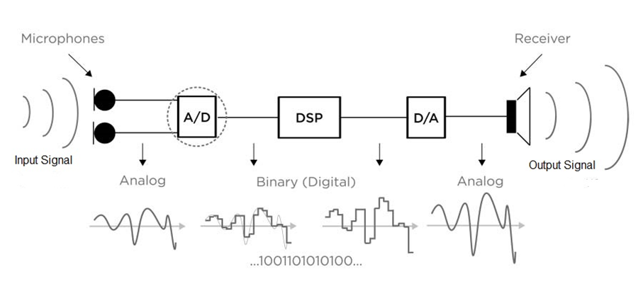

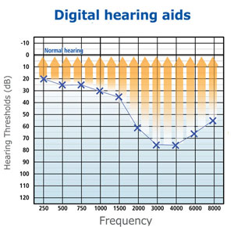*The idea in its simplest form , we take an analog signal by a small condenser electret (or high capture) microphone*

*then pass this signal to our ADC (analog to digital converter )*

*then to our micro-processor in which the DSP (digital signal processing will take place ) in this stage we configure our signal to match the desired output , so we do that by amplifying some frequencies which are barely heard by the person and suppress some frequencies ,*

*after that the signal goes to be digitalize again through DAC (Digital to analog converter)*

*finally the output audio signal will be hopefully on the Bluetooth headset device like an ordinary any Bluetooth headset , except that we’ll have our Bluetooth headset will be optimized for our specific purpose*

***Execution Plan***

First Product :

* Android Studio (Java and C++ libraries dependancies)
* Tested or resulted app on Injoo and Samsung core

Second Product:

* Used dsPic33FJ64GP802 as a Processor Unit for the DSP
* Used Electret Microphone for Capturing the Voice Signal
* Sound Signal Enter the dsPic through ADC Peripheral
* The signal then Sampled and Digitalized and here comes the role of DSP
* After DSP Takes place the Signal is then output on DAC Peripheral of the dsPic
* This Process is controlled over a standalone mobile app that control the dsPic through Bluetooth

Production Phase :

All we need is to combine all the components including:

1. High quality amplifiers
2. Microphones
3. Capacitors and resistors
4. Long-life Battery

Once we collect them all in a well-organized block diagram, we will send it to our contributors in China to start manufacturing our product with a user friendly design.

We will have another contributor to help us delivering our product in Egypt or any place in Africa.

Your fund will decide our start-up quantity from the product.

## The Starting Point: [Select Idea/Proof-of-Concept/Prototype]

Proof of Concept:

We already have done our proof of concept as a Digital Hearing aid

[https://goo.gl/16J9Ba](https://goo.gl/16J9Ba%20) ==> This a video where we are demonstrating our proof of concept on a Raspberry-pi

Protyotype:

Yes we have a prototype of our own, we need to improve some feature in it, but it works

First Product : <https://goo.gl/yq1Fcj>

Second Product : <https://goo.gl/pwHGMf>

## Technical Methods/Approaches

To proceed from the starting point to the project output, certain methods/approaches will be adopted, upon examining a variety of other possible approaches. A clear technical description of the chosen techniques, algorithms is expected to be reported here with justifications of adopting them.

* Research and reading papers
* Proof of concept : <https://goo.gl/16J9Ba>
* Proof of concept (Source Code): https://goo.gl/4GX7fR
* Mobile app Development (1st Product ) : <https://goo.gl/yq1Fcj>
* Circuit Design Hardware (2nd Product): <https://goo.gl/pwHGMf>
* Products Manufacturing: Future Planning
* Testing Products: Future planning
* Product Distribution: In Future

## Work Packages and Reporting Scheme

[https://goo.gl/16J9Ba](https://goo.gl/16J9Ba%20)

## Milestones and Gantt Chart

The project plan is expected to be divided among each milestone, with clear deliverables at the end of each. Notice that the milestone will serve as a checkpoint for the success of the project. Thus, clear measures of success at the end of every milestone should be indicated. Typically a Gantt chart is used to summarize the execution plan flow.

**Pipeline:**

1. **Research & Reading phase (Nov. 2017 to Jan.2018):**
2. **Proof of concept phase (Dec. 2017 to Feb.2018):**

After researching the idea and similar products, this phase has been done with satisfying results.

1. **Prototype phase (Feb. 2018 to May. 2018):**

We have a working prototype using a raspberry pi microcontroller with good accuracy.

1. **Testing Products phase (June. 2018 to July.2018):**

After researching the idea and similar products, this phase has been done with satisfying results.

1. **Product manufacturing (July 2018 to July. 2018):**

This phase will involve prototype enhancement, and finding a way for mass production.

1. **Product distribution (Starting Sep. 2018):**

In this phase we are expecting to have a product ready for the market. And we start delivering to customers.

**Gantt Chart**

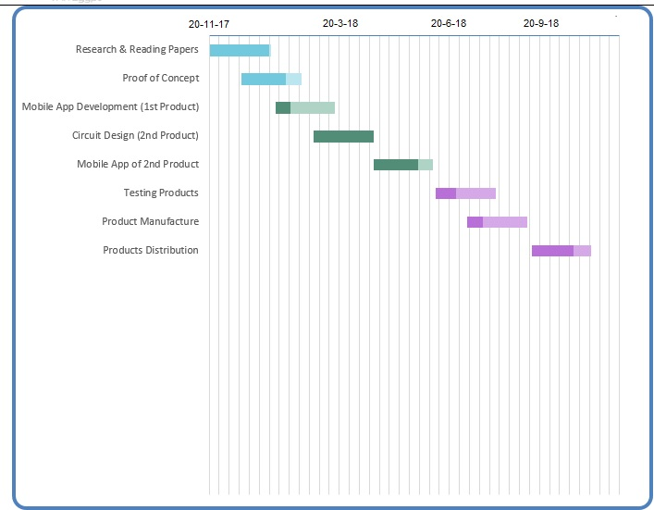

## SWOT Analysis and Mitigation Plan

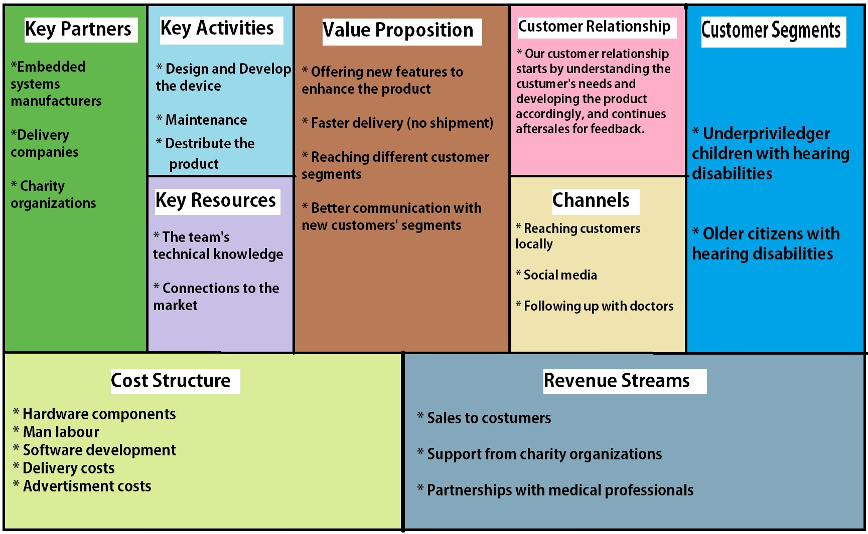**Business Canvas**

*Strengths:*

1. *Our product is cheap, user friendly and save*
2. *Our market has a huge need for such a product*

*Weaknesses:*

1. *The market may not be familiar to our new product*
2. *Our employees may need specific training about this product*

*Opponents:*

1. *The market has a huge need to our cheap and save product*
2. *Great opportunity for huge revenue*

*Threats:*

1. *The market may not be aware of hearing aids*
2. *The competition in the future will be difficult*

# Resources

Detailed description of features of the equipment that will be used in the project and justification for needing them may be given in this section. Distribution of these resources over the milestones may also be given. This section may be combined with other sections if the applicant sees it is better to do so.

*The equipment will be:*

1. *Microphone: to get the voice from the surrounding environment (Micro strong Condenser)*
2. *Amplifiers: to increase the strength of sound signals (*High quality amplifiers)
3. *Capacitors and resistors*
4. *Digital filters: to filter the sound signals and remove the noise*
5. *Long life battery*

*The features will be:*

1. *Ability to filter any surrounding noise*
2. *Maximize the sound signals*
3. *User friendly hearing aid in small shape*
4. *Ability to control the hearing aid from our mobile app and select from many modules*

Once we collect them all in a well-organized block diagram, we will send it to our contributors in China to start manufacturing our product with a user friendly design.

We will have another contributor to help us delivering our product in Egypt or any place in Africa.

Your fund will decide our start-up quantity from the product.

# Budget

## Distribution by Item

Each item in the project (salaries, equipment, travel expenses … etc.) should be tabulated, indicating the ITAC share and the industrial partner contribution. **If other sources of funding are available to the same project, then the budget section should clearly include them.**

These are the components and materials that we would need to start our hearing aid design and sales business:

* Microphone and Amplifier (300 L.E)
* Ear Hook (400 L.E)
* Connecting Tubing (50 L.E)
* Earmold (100 L.E)
* Dspic33f (350 L.E)

## Distribution by Milestone

The distribution of the ITAC share over the project milestones should be given in this section. **Do not forget to refer to the ITAC Financial Rules and Guidelines while preparing the project budget.**

## Projected Income/ROI/Financial Plan

Sales will be slow initially, a function of the fact that Hyper Technology is a start-up organization and it will take time to build a sufficient foundation.

**For the first year:**

**Fixed Cost** = Decoration of the company + Salaries + Marketing +Rent + Electricity + Mobile app

* 50000 + 14x2000x12 + 2000*12 + 5000*12 + 6000 + 4000
* 480 000 L.E

**Variable Cost** = hearing aid

= 650*50 000 = 32 500 000 L.E

**Total Cost** = Fixed Cost + Variable Cost

= 480 000 + 32 500 000 = 32 980 000 L.E

**By selling each hearing aid for 2000 L.E**

|  |  |  |  |
| --- | --- | --- | --- |
|  | **Year 1** | **Year 2** | **Year 3** |
| Mobile app | 4000 L.E | 0 L.E | 0 L.E |
|  |  |  |  |
| Decoration | 50 000 L.E | 0 L.E | 0 L.E |
|  |  |  |  |
| Marketing | 24 000 L.E | 24 000 L.E | 24 000 L.E |
|  |  |  |  |
| Electricity | 6000 L.E | 6000 L.E | 6000 L.E |
|  |  |  |  |
| Salaries | 336 000 L.E | 336 000 L.E | 336 000 L.E |
|  |  |  |  |
| Development expenses | 10 000 L.E | 10 000 L.E | 10 000 L.E |
|  |  |  |  |
| Rent | 60 000 L.E | 60 000 L.E | 60 000 L.E |
|  |  |  |  |
| Hearing aids | 32 500 000 L.E | 32 500 000 L.E | 32 500 000 L.E |
|  |  |  |  |
| **Total Cost** | 32 980 000 L.E | 32 926 000 L.E | 32 926 000 L.E |
|  |  |  |  |
| **Income** | 100 000 000 L.E | 100 000 000 L.E | 100 000 000 L.E |
|  |  |  |  |
| **Revenue** | 67 020 000 L.E | 67 074 000 L.E | 67 074 000 L.E |
|  |  |  |  |

# References

We Ran out of time to the deadline, so we will unfortunately skip this section

# Appendices

We Ran out of time to the deadline, so we will unfortunately skip this section

# Biographies

**Hanna Nabil: Embedded systems technical manager**

-A bachelor's degree in Systems and Biomedical Engineering, Cairo university with a (good) grade (class of 2018)

- Had made Embedded system projects

-Has a Firm background on DSP application with Embedded system

-Hands on android Studio

- Developed Computer Vision and Neural Machine Interface for Upper Limb Prostheses using Machine Learning Techniques (as a Graduation Project)

- GitHub : <https://github.com/hananabilabd>

**Amr Mohamed Ashour: Relations and marketing manager:**

-A bachelor's degree in Systems and Biomedical Engineering, Cairo university with a (good) grade (class of 2018)

Foundation certificate in sales and marketing from AUC

Career certificate in sales management from AUC

Certificate of achievement in sales and marketing from Update organization

Certificate of achievement from Toshiba Medical

Business Model Manager at Beat.

**Conclusion:**

As you can see, we propose to provide a solution to a significant health problem affecting a large demographic of our society. Thus achieving both profit and delivering a value to people’s lives as well as to society over all.

Why us? Because we are qualified engineers working on a product in our field, and we the knowledge and passion to pursue this opportunity from start as far as it takes us.

We will be happy to receive your emails: [hananabilabd@gmail.com](mailto:hananabilabd@gmail.com)